1.
A Project Report On


Franxx

Submitted in partial fulfillment of the requirement for the award of the degree
Master of Computer Applications (MCA)

Academic Year 2026 – 27

Savan Detroja (92500584067)
Jevin Parmar (92500584073)
Aryan Kapadiya (92500584093)

Internal Guide
Dr. Jaypalsinh Gohil



Rajkot-Morbi Road, At &PO :Gauridad, Rajkot 360 003. Gujarat. India.



Faculty of Computer Applications (FoCA)



This is to certify that the project work entitled Franxx submitted in partial fulfillment of the requirement for the award of the degree of
Master of Computer Applications (MCA)
of the

Marwadi University
is a result of the bonafide work carried out by
Savan Detroja (92500584067)
Jevin Parmar (92500584073)
Aryan Kapadiya (92500584093)
during the academic year 2026-27

Faculty Guide |  | HOD |  | Dean

DECLARATION

We hereby declare that this project work entitled Franxx is a record done by us.

We also declare that the matter embodied in this project is genuine work done by us and has not been submitted whether to this University or to any other University / Institute for the fulfillment of the requirement of any course of study.

Place: MARWADI UNIVERSITY
Date: 10/07/2026

Savan Detroja | (92500584067) | Signature:
Jevin Parmar | (92500584073) | Signature:
Aryan Kapadiya | (92500584093) | Signature:

ACKNOWLEDGEMENT

It is indeed a great pleasure to express our thanks and gratitude to all those who helped us. No serious and lasting achievement or success one can ever achieve without the help of friendly guidance and co-operation of so many people involved in the work.

We are very thankful to our guide Dr. Jaypalsinh Gohil , the person who makes us to follow the right steps during our project work. We express our deep sense of gratitude to for his /her guidance, suggestions and expertise at every stage. A part from that his/her valuable and expertise suggestion during documentation of our report indeed help us a lot.

Thanks to our friend and colleague who have been a source of inspiration and motivation that helped to us during our project work.

We are heartily thankful to the Dean of our department Dr. Rijwan Khan sir and HoD Dr. Sunil Bajeja sir for giving us an opportunity to work over this project and for their end-less and great support to all other people who directly or indirectly supported and help us to fulfil our task.

Savan Detroja (92500584067) Signature: Jevin Parmar (92500584073) Signature: Aryan Kapadiya (92500584093) Signature:

CONTENTS

Chapters | Particulars | Page No.
1 | Introduction to Project Definition | 1
2  2.1 | PREAMBLE  Module description | 2  3
3 | REVIEW OF LITERATURE  Analyze, Study and Compare the similar types of the systems/applications and highlights major findings | 5
4  4.1  4.2 | TECHNICAL DESCRIPTION  Hardware Requirement Software Requirement | 7
5  5.1  5.2  5.3  5.4  5.5  5.6  5.7  5.8 | SYSTEM DESIGN AND DEVELOPMENT  - - Flow Chart  - - Data Flow Diagram  - - Class Diagram  - - Use Case Diagram  - - Sequential Diagram  - - Activity Diagram  - Screen Design  - Database Design / File Structure | 8  9  10  11  12  13  14  15
6 | SYSTEM TESTING | 23
7 | CONCLUSION | 28
8  8.1 | LEARNING DURING PROJECT WORK  Future Enhancement | 29  30
9  9.1  9.2 | BIBLIOGRAPHY  Online References Offline References | 31

Table Index

Sr No. | Table No. | Particulars | Page No.
1 | Table 4.1 | Hardware Requirement | 7
2 | Table 4.2 | Software Requirement | 7
3 | Table 5.8 | Users Collection | 20
4 | Table 5.8.1 | Chat Collection | 20
5 | Table 5.8.2 | Messages Collection | 21
6 | Table 5.8.3 | Status Collection | 21
7 | Table 5.8.4 | Notifications Collection | 22
8 | Table 5.8.5 | Settings Collection | 22
9 | Table 6 | Registration & Login Testing | 23
10 | Table 6.1 | Private Chat Testing | 23
11 | Table 6.2 | Chat Testing | 23
12 | Table 6.3 | User Search & Connection Testing | 24
13 | Table 6.4 | User Profile Testing | 25
14 | Table 6.5 | Status Testing | 25
15 | Table 6.6 | Media & File Sharing Testing | 26
16 | Table 6.7 | Notification Testing | 26
17 | Table 6.8 | Settings Testing | 27
18 | Table 6.9 | Admin Panel Testing | 27

Figure Index

Sr No. | Figure No. | Particulars | Page No.
1 | Figure 5.1 | Flow Chart | 8
2 | Figure 5.2 | Data Flow Diagram | 9
3 | Figure 5.3 | Class Diagram | 10
4 | Figure 5.4 | Use Case Diagram | 11
5 | Figure 5.5 | Sequential Diagram | 12
6 | Figure 5.6 | Activity Diagram | 13
7 | Figure 5.7 | User Search Page | 14
8 | Figure 5.7.1 | Status page | 15
9 | Figure 5.7.2 | Media and Gallery page | 17
10 | Figure 5.7.3 | Settings page | 17
11 | Figure 5.7.4 | Profile page | 18
12 | Figure 5.7.5 | Admin Dashboard page | 18
13 | Figure 5.7.6 | User Panel page | 19

Introduction Project Description

Communication has become one of the most essential parts of modern digital life. Existing messaging applications provide users with secure and fast communication, but developing such a platform helps students understand full-stack application development and real-time communication technologies.

FRANXX is designed as a modern messaging platform inspired by popular applications such as WhatsApp, Discord, Telegram, and Messenger. The application provides a secure environment where registered users can communicate with other users through private chats or group conversations.

The system uses MongoDB for storing user information, chat history, media details, and group information. Express.js and Node.js handle server-side operations, authentication, and APIs, while React.js provides an interactive and responsive user interface. Socket.IO enables real-time message delivery without requiring users to refresh the page.

The application also includes an administrator module that allows administrators to manage users, monitor chats, handle reports, and maintain the overall system.

The system is designed to be scalable, user-friendly, and secure while following modern software development practices.

PREAMBLE

FRANXX is a web-based real-time chat application developed using the MERN stack. It allows users to register, securely log in, search and connect with other users, send private messages, create group chats, share media and files, and post temporary statuses. The system also provides notifications, user profiles, settings, and an admin panel for managing users and application activities. The main aim of FRANXX is to provide a simple, secure, and user-friendly platform for real-time communication.

2.1 Module Description

User Authentication Module
  - User registration, login and logout.
  - Secure password encryption and JWT authentication.
  - Protected routes and session management.

Dashboard Module
  - Displays recent chats, online users and latest messages.
  - Provides quick access to search, profile and settings.
  - Acts as the main screen after successful login.

Private Chat Module
  - Real-time one-to-one messaging between users.
  - Supports text messages, emojis, images and file sharing.
  - Shows message time, seen status, chat history and shared media.

Group Chat Module
  - Users can create groups and communicate with multiple members.
  - Supports adding/removing members, group image and description.
  - Group admin can manage members and group information.

User Profile Module
  - View and edit profile picture, username, email and about information.
  - Shows online status and last seen.
  - Users can view their own profile as well as other users' profiles.

User Search and Connection Module
  - Search registered FRANXX users by name or username.
  - View searched user's profile.
  - Send connection/friend request and start a private chat after connection.

Followers and Following Module
  - Manage followers and following users.
  - Accepted connections are displayed in the user's network.
  - Connected users can easily access each other from the chat section.

Status Module
  - Upload temporary text or image status.
  - View status updates shared by connected/following users.
  - Users can also delete their own status.

Media and File Sharing Module
  - Share images, videos, documents and other supported files in chats.
  - View shared media and files from conversations.
  - Download shared files when required.

Notification Module
  - Provides notifications for new messages and user activities.
  - Shows friend/connection requests and group-related notifications.
  - Helps users stay updated without manually checking each section.

Settings Module
  - Edit account information and change password.
  - Manage notification, privacy, security and theme settings.
  - Provides logout and other account management options.

Admin Module
  - Provides a separate dashboard for administrators.
  - Manage users, chats, groups and reported activities.
  - View application statistics, system logs and overall platform activity.

3.REVIEW OF LITERATURE

Analysis, Study and Comparison of Similar Systems A literature review was conducted to study existing messaging and social communication platforms. The analysis helped to understand their important features, strengths and limitations. These systems were studied as references for developing the FRANXX.

WhatsApp
Description:
WhatsApp is a popular messaging application that allows users to communicate through private and group chats.

Strengths:
  - Fast real-time private and group messaging.
  - Supports images, videos, documents and status sharing.
  - Provides online status, last seen and message status.

Limitations:
  - Mainly depends on phone numbers for connecting users.
  - Provides limited public user-search functionality.
  - Limited community/profile discovery compared to social platforms.

Telegram Description:
Telegram is a cloud-based messaging application that provides private chats,
groups and media sharing.

Strengths:
  - Fast real-time messaging.
  - Supports large groups and file sharing.
  - Users can be searched using usernames.

Limitations:
  - Contains many advanced features that can make the application complex.
  - Some privacy and messaging features may be difficult for new users to understand.

Discord Description:
Discord is a communication platform that provides private messaging, group communication and community-based servers.

Strengths:
  - Real-time communication.
  - Supports private and group conversations.
  - Provides online status and media/file sharing.

Limitations:
  - Mainly designed around communities and servers.
  - Interface can be complex for users who only need simple messaging.
  - Many features are unnecessary for basic personal communication.

Instagram Description:
Instagram is a social networking platform that also provides private messaging,
user profiles, followers and temporary status/story sharing.

Strengths:
  - Users can search for other users easily.
  - Provides followers and following functionality.
  - Supports private messaging and story/status sharing.

Limitations:
- Mainly focused on social media and content sharing.
- Messaging is not the primary purpose of the platform.
- Contains many features unrelated to a dedicated chat application.

- TECHNICAL DESCRIPTION

Hardware Requirement

Component | Minimum Requirement
Processor | Intel Core i3 or AMD equivalent
RAM | 4 GB (8 GB Recommended)
Hard Disk | 20 GB Free Space
Internet Connection | Broadband/Wi-Fi
Table 4.1 Hardware Requirement

Software Requirement

Software | Requirement
Operating System | Windows 10/11, Linux, or macOS
Frontend | React.js, HTML5, CSS3, JavaScript, Bootstrap/Tailwind CSS
Backend | Node.js, Express.js
Database | MongoDB
Runtime Environment | Node.js (v18 or above)
IDE | Visual Studio Code
API Testing Tool | Postman
Version Control | Git and GitHub
Web Browser | Google Chrome, Microsoft Edge, Mozilla Firefox
Package Manager | npm (Node Package Manager)
Table 4.2 Software Requirement

- SYSTEM DESIGN AND DEVELOPMENT

Flowchart

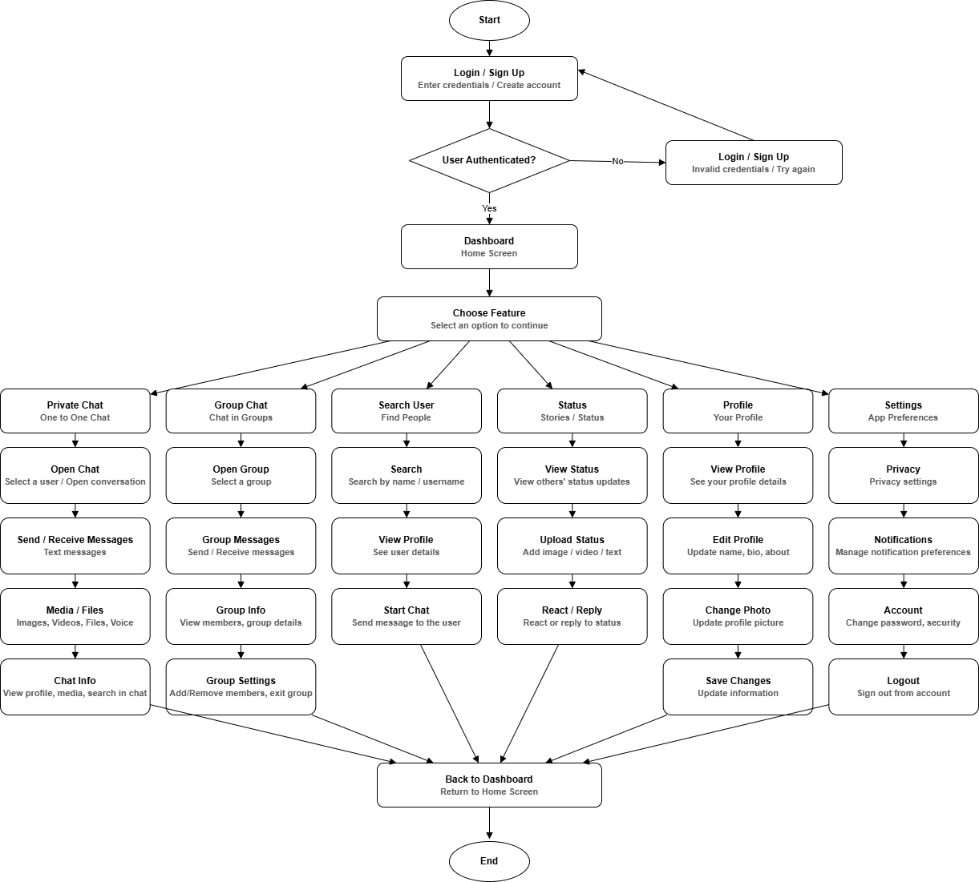

Figure 5.1 Flowchart

Data Flow Diagram

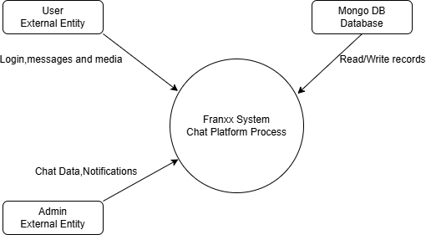

Level - 0

Figure 5.2 Data Flow Diagram

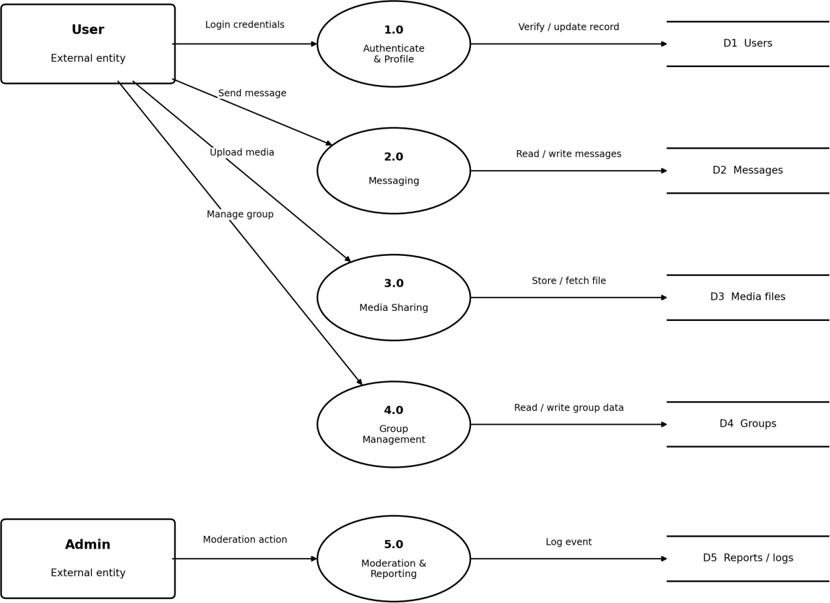

Level - 1

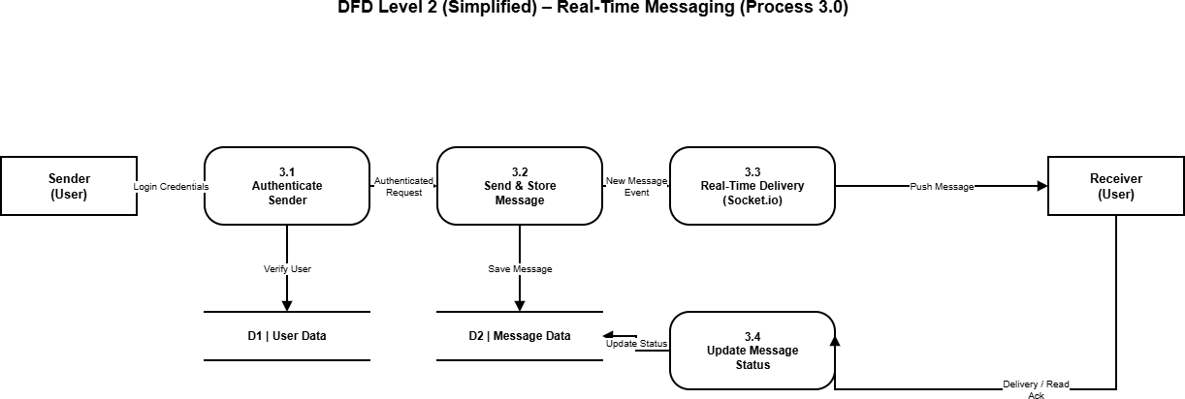

Level - 2 DFD Messaging

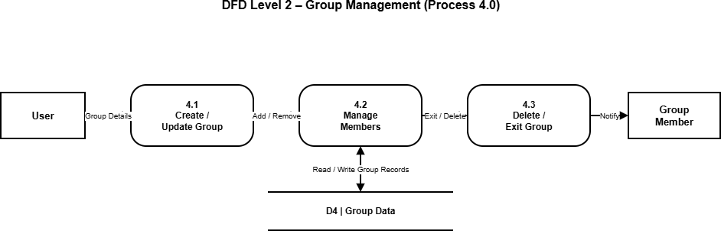

Level - 2 DFD Group Management

  - Class Diagram
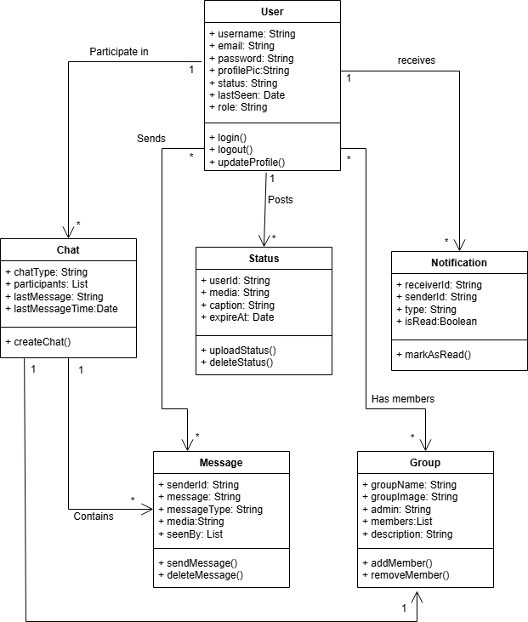

Figure 5.3 Class Diagram

Use Case Diagram

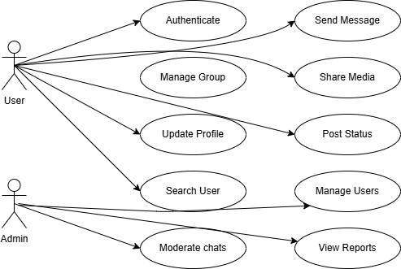

Figure 5.4 Use Case Diagram

Sequential Diagram
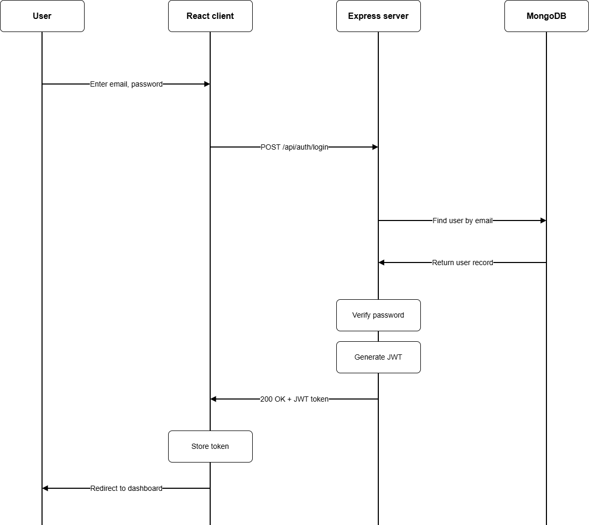

Figure 5.5 Sequential Diagram

Activity Diagram

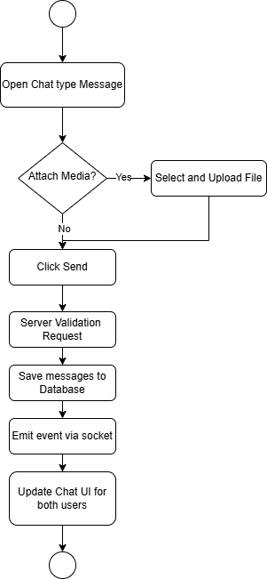

Figure 5.6 Activity Diagram

  - Screen Design

- User Search Page
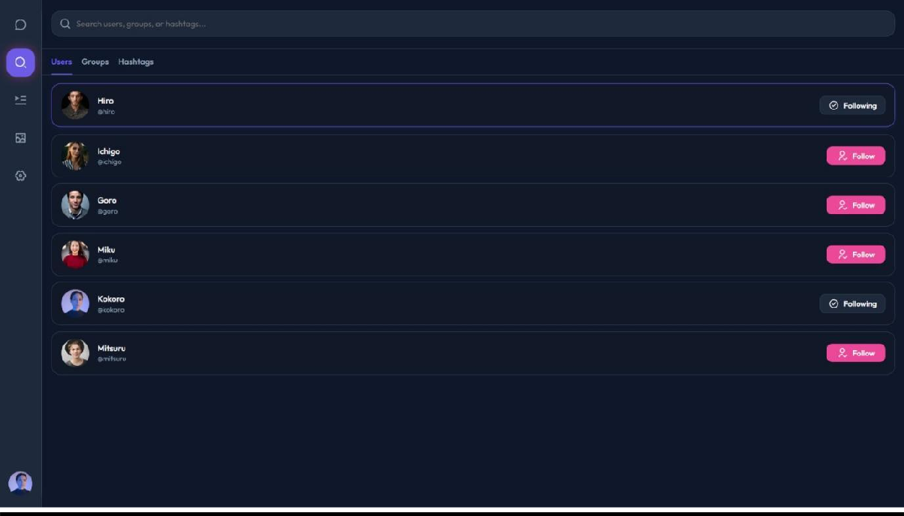
Figure 5.7 User Search Page
- Status
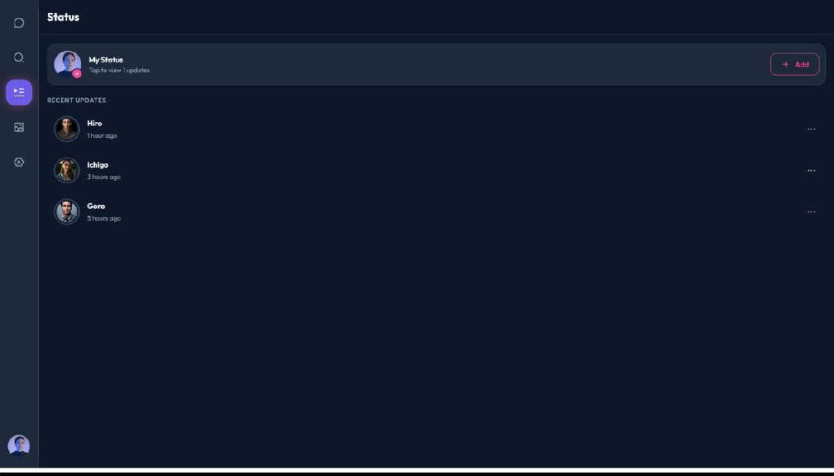
Figure 5.7.1 Status page

- Media and Gallery
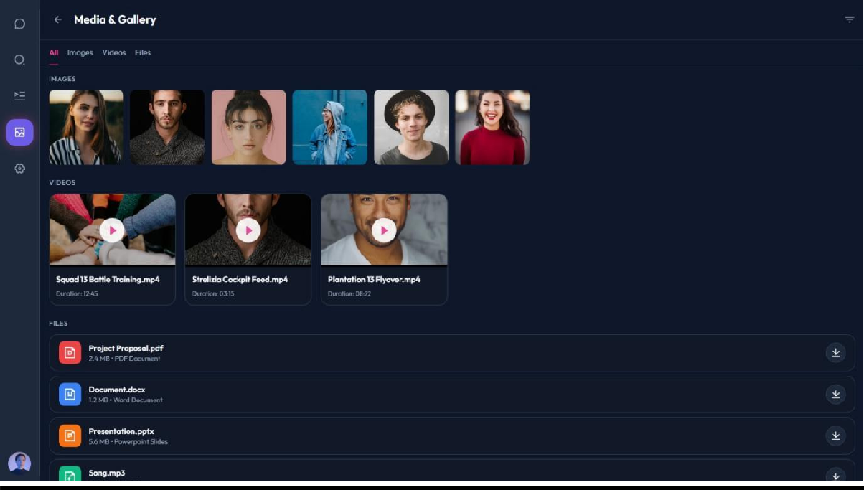
Figure 5.7.2 Media and Gallery page
- Settings
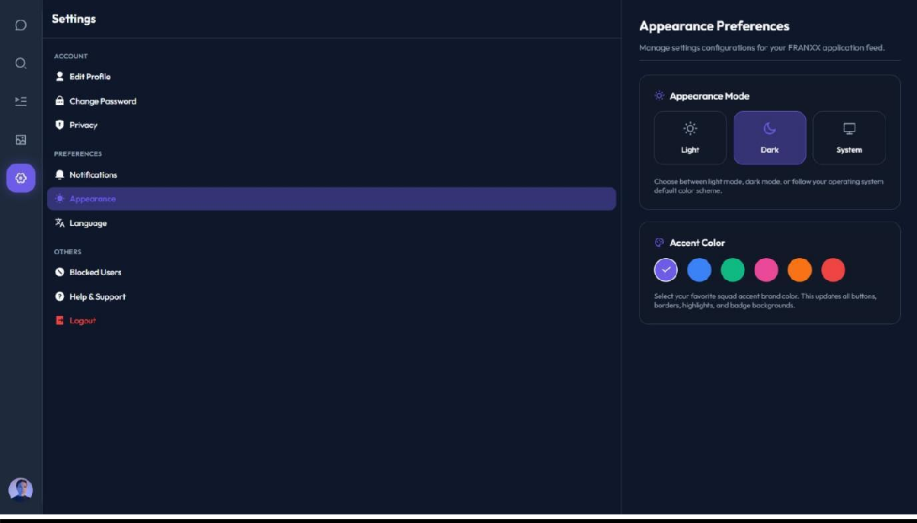
Figure 5.7.3 Settings page

- Profile
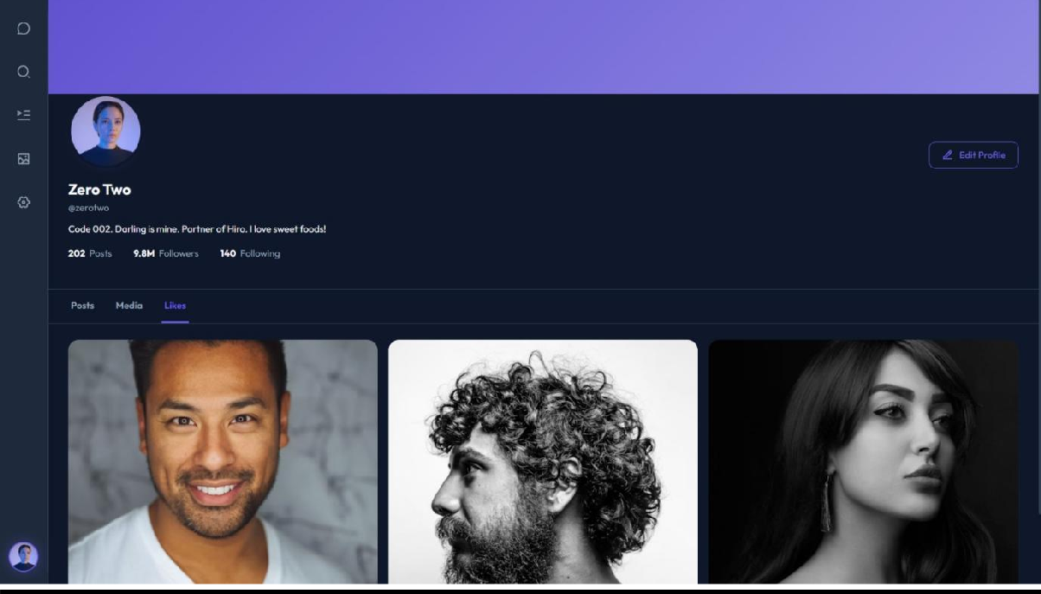
Figure 5.7.4 Profile page
- Admin Dashboard
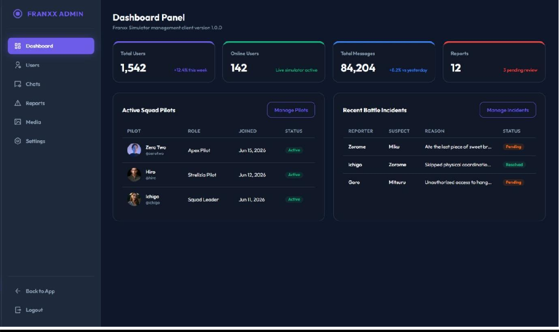
Figure 5.7.5 Admin Dashboard page

- User Panel
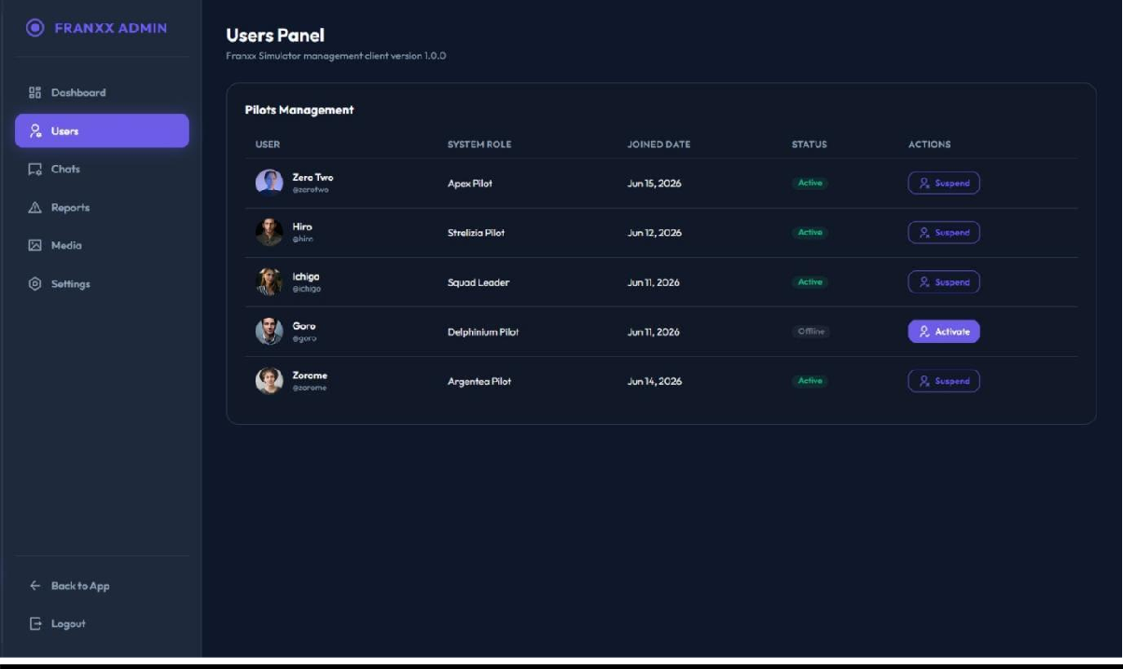
Figure 5.7.6 User Panel page

5.8 Database Structure

- Users Collection
Field Name | Data Type | Key Constraint | Description
_id | ObjectId | Primary Key | Unique identifier for each user.
fullName | String | Required | User's full name.
username | String | Unique, Required | Unique username.
email | String | Unique, Required | User email address.
password | String | Required | Bcrypt hashed password.
profilePic | String | Optional | Profile image URL.
bio | String | Optional | User biography.
phone | String | Optional | Mobile number.
isOnline | Boolean | Default: false | User online status.
lastSeen | Date | System Generated | Last active timestamp.
createdAt | Date | System Generated | Account creation time.
updatedAt | Date | System Generated | Last update time.
Table 5.8 Users Collection
- Chat Collection
Field Name | Data Type | Key Constraint | Description
_id | ObjectId | Primary Key | Unique chat ID.
chatType | String | Required | Private or Group.
participant s | Array(ObjectId  ) | Required | List of participant IDs.
groupName | String | Optional | Group name.
groupImag e | String | Optional | Group profile image.
admins | Array(ObjectId  ) | Optional | Group admin IDs.
createdBy | ObjectId | Foreign Key | User who created the group.
lastMessag e | ObjectId | Foreign Key | Latest message ID.
createdAt | Date | System Generated | Chat creation date.
updatedAt | Date | System  Generated | Last update date.
Table 5.8.1 Chat Collection

- Messages Collection
Field Name | Data Type | Key Constraint | Description
_id | ObjectId | Primary Key | Unique message ID.
chatId | ObjectId | Foreign Key | Chat reference.
senderId | ObjectId | Foreign Key | Sender ID.
message | String | Optional | Text message.
messageTy pe | String | Required | Text, Image, Video, Audio, File.
mediaUrl | String | Optional | Uploaded media URL.
replyTo | ObjectId | Optional | Reply message ID.
seenBy | Array(ObjectI d) | Optional | Users who have seen the message.
deletedFor | Array(ObjectI d) | Optional | Users who deleted the message.
createdAt | Date | System Generated | Message timestamp.
updatedAt | Date | System Generated | Last edit timestamp.
Table 5.8.2 Messages Collection
- Status Collection
Field Name | Data Type | Key Constraint | Description
_id | ObjectId | Primary Key | Unique status ID.
userId | ObjectId | Foreign Key | User who posted status.
mediaUrl | String | Required | Image or video URL.
caption | String | Optional | Status caption.
viewers | Array(ObjectId  ) | Optional | Users who viewed the status.
expiresAt | Date | Required | Status expiry (24 hours).
createdAt | Date | System Generated | Upload timestamp.
Table 5.8.3 Status Collection

- Notifications Collection
Field Name | Data Type | Key Constraint | Description
_id | ObjectId | Primary Key | Notification ID.
userId | ObjectId | Foreign Key | Receiver ID.
senderId | ObjectId | Foreign Key | Sender ID.
type | String | Required | Message, Group, Status.
title | String | Required | Notification title.
body | String | Required | Notification content.
isRead | Boolean | Default: false | Read status.
createdAt | Date | System Generated | Notification time.
Table 5.8.4 Notifications Collection

- Settings Collection
Field Name | Data Type | Key Constraint | Description
_id | ObjectId | Primary Key | Setting ID.
userId | ObjectId | Foreign Key | User reference.
theme | String | Default: Light | App theme.
language | String | Default: English | Preferred language.
notifications | Boolean | Default: true | Notification preference.
privacy | String | Default: Everyone | Privacy setting.
lastSeenVisibility | String | Default: Everyone | Last seen visibility.
createdAt | Date | System Generated | Created timestamp.
updatedAt | Date | System Generated | Last updated timestamp.
Table 5.8.5 Settings Collection

SYSTEM TESTING

  - Registration & Login Testing
Test case id | Test case objective | Pre-requisite | Steps |  |  | Input data |  | Expected output |  | Actual output | Statu s
Tc_0 1 | Test user registratio n | Registratio n page  should be accessible | - Open sign up page  - Enter details  - Click sign up |  |  | Name, username, email,  password |  | User account should be  created |  | Account created successfull  y | Pass
Tc_0 2 | Test user login | User should be registered | - Open login page  - Enter email/usernam e  - Enter password  - Click login |  |  | Valid login details |  | User should login successfull y |  | User logged in successfull y | Pass
Tc_0 3 | Test invalid login | Login page should be accessible | - Enter invalid email  - Enter  incorrect password  - Click login |  |  | Incorrect email/passwor d |  | Error message should be displayed |  | Error message displayed | Pass
Tc_0 4 | Test logout | User should be logged in | - Open  settings/profile  - Click logout |  |  | Logged-in user |  | User should logout |  | User logged out successfull y | Pass
Table 6 Registration & Login Testing
6.2 Private Chat Testing
Test case id | Test case objective | Pre-requisite |  | Steps | Input data |  | Expected output |  | Actual output |  | Status
Tc_05 | Test private chat | Two users  should be connected |  | - Select  user 2.  Open chat | Selected user |  | Private chat should open |  | Chat opened successfully |  | Pass
Tc_06 | Test send message | Chat should be open |  | - Type message  - Click send | "hello" |  | Message should be sent |  | Message sent successfully |  | Pass
Tc_07 | Test receive message | Both users  should be online |  | - User a sends message  - Check user b | Text message |  | Message should appear in real time |  | Message received successfully |  | Pass
Tc_08 | Test chat history | Previous messages should exist |  | - Open existing chat | Existing conversation |  | Previous messages should be displayed |  | Chat history displayed |  | Pass
Tc_09 | Test emoji | Chat should be open |  | - Open emoji option  - Select emoji  - Send | ^•●- |  | Emoji should be sent |  | Emoji sent successfully |  | Pass
Tc_10 | Test message seen status | Message should be sent |  | - Send message  - Receiver opens chat | Sent message |  | Seen status should update |  | Seen status updated |  | Pass

Table 6.1 Private Chat Testing

6.3 Chat Testing
Test case id | Test case objective |  | Pre-requisite |  | Steps | Input data | Expected output |  | Actual output | Status
Tc_11 | Test group creation |  | User should be logged in |  | - Open groups  - Create group  - Add  members | Group name, members | Group should created | be | Group created successfully | Pass
Tc_12 | Test group message |  | Group should exist |  | - Open  group 2. Type message  3. Send | "hello group" | All members should receive message |  | Message received by members | Pass
Tc_13 | Test add member |  | Group admin required |  | - Open group info  - Select add member  - Select user | Registered user | User should be added |  | Member added successfully | Pass
Tc_14 | Test remove member |  | Group admin required |  | - Open members  - Select user  - Remove | Group member | Member should removed | be | Member removed successfully | Pass
Tc_15 | Test group information |  | Group should exist |  | - Open group  - Click  group header | Existing group | Group details should display |  | Group details displayed | Pass
Table 6.2 Chat Testing
6.4 User Search & Connection Testing
Test case id | Test case objective |  | Pre-requisite |  | Steps | Input data | Expected output |  | Actual output | Status
Tc_16 | Test user search | User should be logged in |  |  | - Open  search 2.  Enter username | Username | Matching users should display |  | Users displayed successfully | Pass
Tc_17 | Test invalid search |  | Search page should open | be | - Enter unknown username  - Search | Invalid username | No user/result message should appear |  | No result displayed | Pass
Tc_18 | Test user profile |  | User should  appear search | in | - Search user  - Click profile | Registered user | User profile should open |  | Profile opened successfully | Pass
Tc_19 | Test connection request | Another user should exist |  |  | - Search user  - Click add | Selected user | Request should sent | be | Request sent successfully | Pass
Tc_20 | Test accept request | Request should exist |  |  | - Open notification  - Accept request | Pending request | Users should be connected |  | Connection created successfully | Pass
Table 6.3 User Search & Connection Testing

6.5 User Profile Testing
Test case id | Test case objective |  | Pre-requisite | Steps | Input data |  | Expected output |  |  | Actual output | Status
Tc_21 | Test view profile |  | User should be logged in | - Open profile | User account |  | Profile information should display |  | Profile displayed successfully |  | Pass
Tc_22 | Test edit profile |  | Profile should exist | - Click edit  - Change details  - Save | Name, about |  | Profile should update |  | Profile updated successfully |  | Pass
Tc_23 | Test profile picture |  | User should be logged in | - Edit  profile  - Select image  - Save | Image file |  | Profile picture should update |  | Picture updated successfully |  | Pass
Tc_24 | Test other user profile |  | Another user should exist | - Search user  - Open profile | Selected user |  | Other user's profile should display |  | Profile displayed successfully |  | Pass
Table 6.4 User Profile Testing

6.6 Status Testing
Test case id | Test case objective |  | Pre-requisite | Steps |  | Input data |  | Expected output |  | Actual output | Status
Tc_25 | Test text status | User should be logged in |  | - Open status  - Add text  - Upload |  | "good morning" |  | Text status should upload |  | Status uploaded  successfully | Pass
Tc_26 | Test image status | Status page should be accessible |  | - Select image  - Upload |  | Image |  | Image status should upload |  | Image uploaded successfully | Pass
Tc_27 | Test status visibility | Users should be connected |  | - User a uploads status  - User b opens status |  | User a's status |  | Connected user should see status |  | Status displayed successfully | Pass
Tc_28 | Test status privacy | Users should not be  connected |  | - Upload status  - Check  from non-  follower account |  | Status |  | Non-follower should not see status |  | Status not displayed | Pass
Tc_29 | Test delete status | Status should exist |  | - Open own status  - Click delete |  | Existing status |  | Status should be deleted |  | Status deleted successfully | Pass
Table 6.5 Status Testing

6.7 Media & File Sharing Testing
Test case id | Test case objective | Pre-requisite |  | Steps |  | Input data |  | Expected output |  | Actual output | Status
Tc_30 | Test image sharing | Chat should be open |  | - Click attachment  - Select image  - Send |  | Image |  | Image should be shared | Image shared successfully |  | Pass
Tc_31 | Test document  sharing | Chat should be  open |  | - Select document  - Send |  | Pdf/document |  | File should be shared | File shared successfully |  | Pass
Tc_32 | Test shared media | Shared media should  exist |  | - Open chat info  - Open media |  | Shared files |  | Shared media should  display | Media displayed successfully |  | Pass
Tc_33 | Test file download | Shared file  should exist |  | - Select file  - Click download |  | Shared file |  | File should download | File  downloaded successfully |  | Pass
Table 6.6 Media & File Sharing Testing

6.8 Notification Testing
Test case id | Test case objective |  | Pre-requisite |  | Steps | Input data |  | Expected output |  | Actual output | Status
Tc_34 | Test message notification |  | Two users should exist |  | - User a sends message  - Check user b | New message | Notification should appear |  |  | Notification displayed | Pass
Tc_35 | Test request notification |  | Users should not be  connected |  | - User a sends request  - Check user b | Connection request | Request notification should appear |  |  | Notification displayed | Pass
Tc_36 | Test group notification |  | User should be group member |  | - Send group activity  - Check member | Group activity | Group notification should appear |  |  | Notification displayed | Pass
Table 6.7 Notification Testing

6.9 Settings Testing
Test case id | Test case objective |  | Pre-requisite |  | Steps | Input data | Expected output | Actual output | Status
Tc_37 | Test change password |  | User should be logged in |  | - Open settings  - Change password  - Save | Old and new password | Password should update | Password updated successfully | Pass
Tc_38 | Test theme settings |  | Settings  should be accessible |  | - Open  theme 2.  Select theme | Dark/light | Theme  should change | Theme  changed successfully | Pass
Tc_39 | Test privacy settings |  | User should be logged in |  | - Open privacy  - Change setting  - Save | Privacy option | Setting should update | Setting updated successfully | Pass
Table 6.8 Settings Testing

6.10 Admin Panel Testing
Test case id | Test case objective |  | Pre-requisite | Steps |  | Input data | Expected output | Actual output | Status
Tc_40 | Test admin login | Admin account should exist |  | - Open admin login  - Enter  credentials  - Login |  | Admin credentials | Admin dashboard should open | Dashboard opened successfully | Pass
Tc_41 | Test view users | Admin should be  logged in |  | - Open user management |  | Registered users | All users should  display | Users displayed  successfully | Pass
Tc_42 | Test search user | Admin should be logged in |  | - Open users  - Search user |  | Username | Matching user should display | User displayed successfully | Pass
Tc_43 | Test block user | User should exist |  | - Select user  - Click block |  | Selected user | User should be blocked | User blocked successfully | Pass
Tc_44 | Test delete user | User should exist |  | - Select user  - Click delete  - Confirm |  | Selected user | User should be deleted | User deleted successfully | Pass
Tc_45 | Test admin security | Normal user should be logged in |  | - Enter admin dashboard url |  | Normal user | Access should be denied | Access denied successfully | Pass
Table 6.9 Admin Panel Testing

CONCLUSION

The FRANXX Real-Time Chat Application was developed to provide a simple and useful platform for online communication. The application allows registered users to search for other users, communicate through private and group chats, share media, upload status updates and manage their profiles.

The project helped in understanding how a real-time web application works from both the frontend and backend sides. Technologies such as React.js, Node.js, Express.js, MongoDB and Socket.IO were used together to develop the complete application.

The main objective of the project was to build a real-time communication system with useful messaging and social features. Most of the planned modules were successfully implemented and tested. The project can also be improved further by adding more advanced communication and security features in the future.

- LEARNING DURING PROJECT WORK

During the development of the FRANXX project, I learned many practical concepts that were different from only studying programming theory.
I learned how frontend and backend applications communicate using APIs and how data can be stored and managed using MongoDB. I also understood how JWT authentication can be used to protect user accounts and application routes.

One of the important parts of this project was real-time communication. By working with Socket.IO, I learned how messages can be sent and received without refreshing the page. I also learned about online/offline status, typing indicators and real-time notifications.

While developing the project, I faced different problems related to APIs, database data, message handling, user authentication and frontend state. Finding and solving these problems improved my debugging and problem-solving skills.
The project also improved my knowledge of:
- React.js and component-based frontend development.
- Node.js and Express.js for backend development.
- MongoDB and database operations.
- REST API development and integration.
- JWT authentication and route protection.
- Socket.IO and real-time communication.
- Git and GitHub for source code management.

Overall, this project gave me practical experience in developing a complete MERN stack application.

Future Enhancement

FRANXX currently provides the main features required for a real-time chat application. However, some additional features can be added in future versions.
  - Voice Calling: Users can communicate through real-time voice calls.
  - Video Calling: One-to-one and group video calling can be provided.
  - Message Reactions: Users can react to messages using emojis.
  - Reply and Forward: Messages can be replied to and forwarded to other chats.
  - Message Editing: Users can edit already sent messages within a limited time.
  - Advanced Privacy: More options can be provided for last seen, profile picture and status visibility.
  - Push Notifications: Users can receive notifications even when the application is not currently open.
  - End-to-End Encryption: Advanced encryption can be implemented to improve message privacy.
  - Voice Messages: Users can record and send voice messages.
  - Mobile Application: A mobile version of FRANXX can be developed for Android and iOS.
  - Cloud Storage: Shared images, videos and documents can be stored using a cloud storage service.
  - Advanced Admin Monitoring: More detailed reports and system activity information can be provided to administrators.

These improvements can make FRANXX more useful, secure and suitable for a larger number of users.

Bibliography

Online References

- MongoDB Inc., “MongoDB Documentation,” [online]. Available: https://www.mongodb.com/docs/. [Accessed: July 10, 2026].
- React, “React Documentation,” [online]. Available: https://react.dev/.
[Accessed: June 20, 2026].

- Node.js, “Node.js Documentation,” [online]. Available: https://nodejs.org/docs/latest/api/. [Accessed: July 25, 2026].
- Express.js, “Express Documentation,” [online]. Available: https://expressjs.com/. [Accessed: August 5, 2026].
- MDN Web Docs, “JavaScript Documentation,” [online]. Available: https://developer.mozilla.org/en-US/docs/Web/JavaScript. [Accessed: August 14, 2026].

Offline References

Text Book:
[1] Software Engineering – A Practitioner’s Approach, Roger S. Press-man, McGraw Hill, 7th Edition.
[2] Unified Modeling Language – User’s Guide, Grady Booch, James Rumbaugh, Ivar Jacobson, Addison – Wesley, 2nd Edition
[3] Object Oriented Modeling and Design using UML, Michael Blaha and James Rambaugh, Pearson Education, 2nd edition

